**PROBLEM:**

Create a boat out of paper and duct tape capable of holding a load, and estimate the water displacement level of the entire system when placed in a bucket of water.

**ASSUMPTIONS:**

* The density of water is 1000 kg/ $m^{3}$
* radius of water bucket ≈ 10.625 in

**METHOD:**

* Using Archimedes' Principle of the buoyant force being equal to the weight of the body floating, multiply the mass of the boat system by gravity to obtain the buoyant force. Then, equating that to the alternative form of this equation, 

with *p* being the density of the fluid, *V ${}_{disp }$*being the volume of displaced fluid, and *g* being the gravitational constant. Because the boat being constructed is a rectangle, V ${}_{disp }$ will be (L x W x dh) where L and W are the same as the length and width of the boat, 7.5 in, and dh is the height of the displaced water. Thus, rearranging this equation will yield

dh = $\frac{B}{pLWg}$

* Using the result from this, an estimation of the height of volume displacement can be obtained, and marked on the boat to test.

**PROCEDURE:**

* measure the radius of the water bucket, using this to obtain an estimate of the max length and width of the boat.
* After obtaining this, begin construction by drawing a box in the middle of the given poster paper with the found dimensions. So long as the height of the box is greater than dh,
* Cut out the box and fold along the edges, taping the sides together with duct tape. Make sure to leave the top of the “boat” open.
* After the box is taped together, cover the bottom of the boat with duct tape to aid in waterproofing.
* Finally, create two crossbars out of the leftover paper by rolling strips into cylinders roughly the length of the hypotenuse of the length and width of the bottom face. This is to prevent the walls of the boat from bowing in once placed into the water and weighed down by the gravel.
* After construction is complete, mark the dh on the side of the boat, and test in the water bucket.

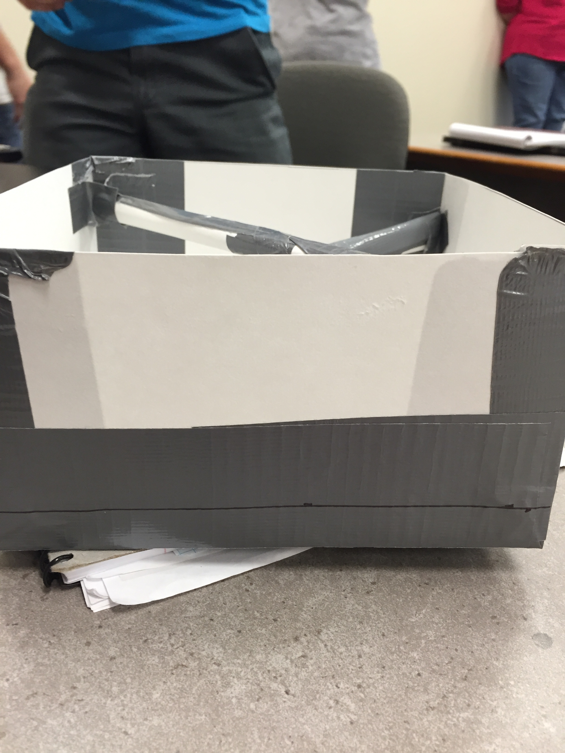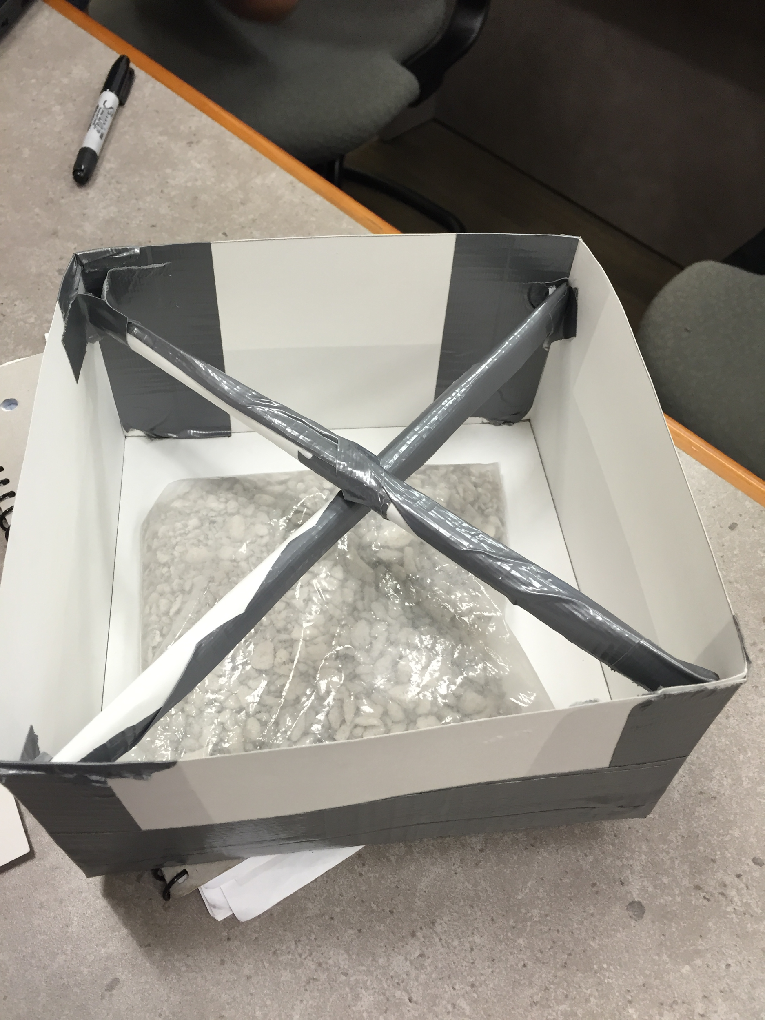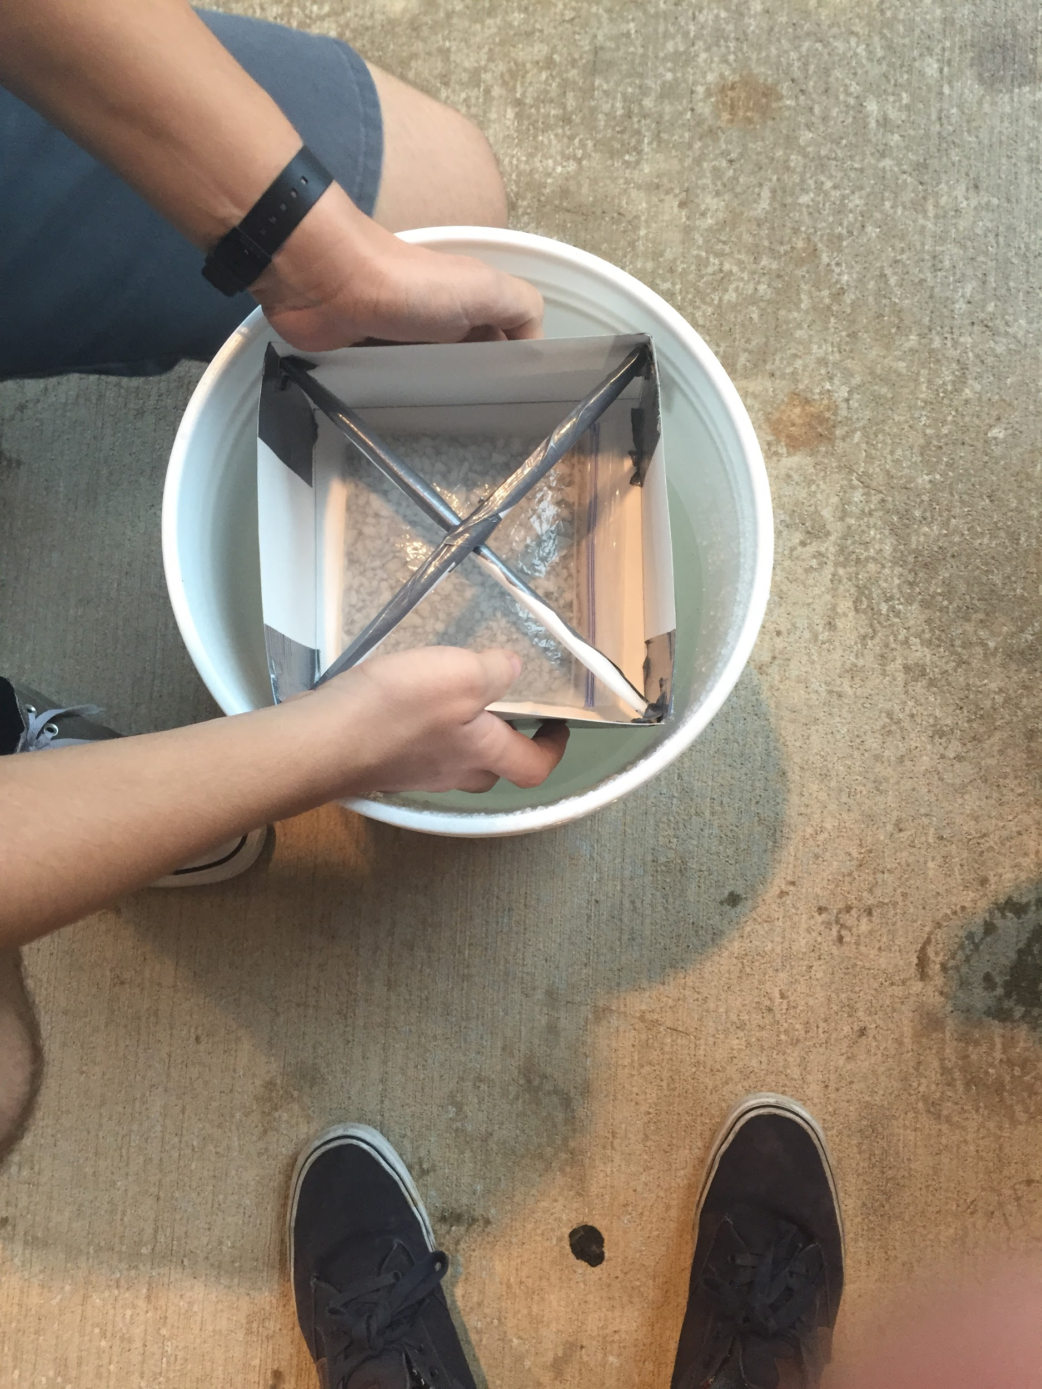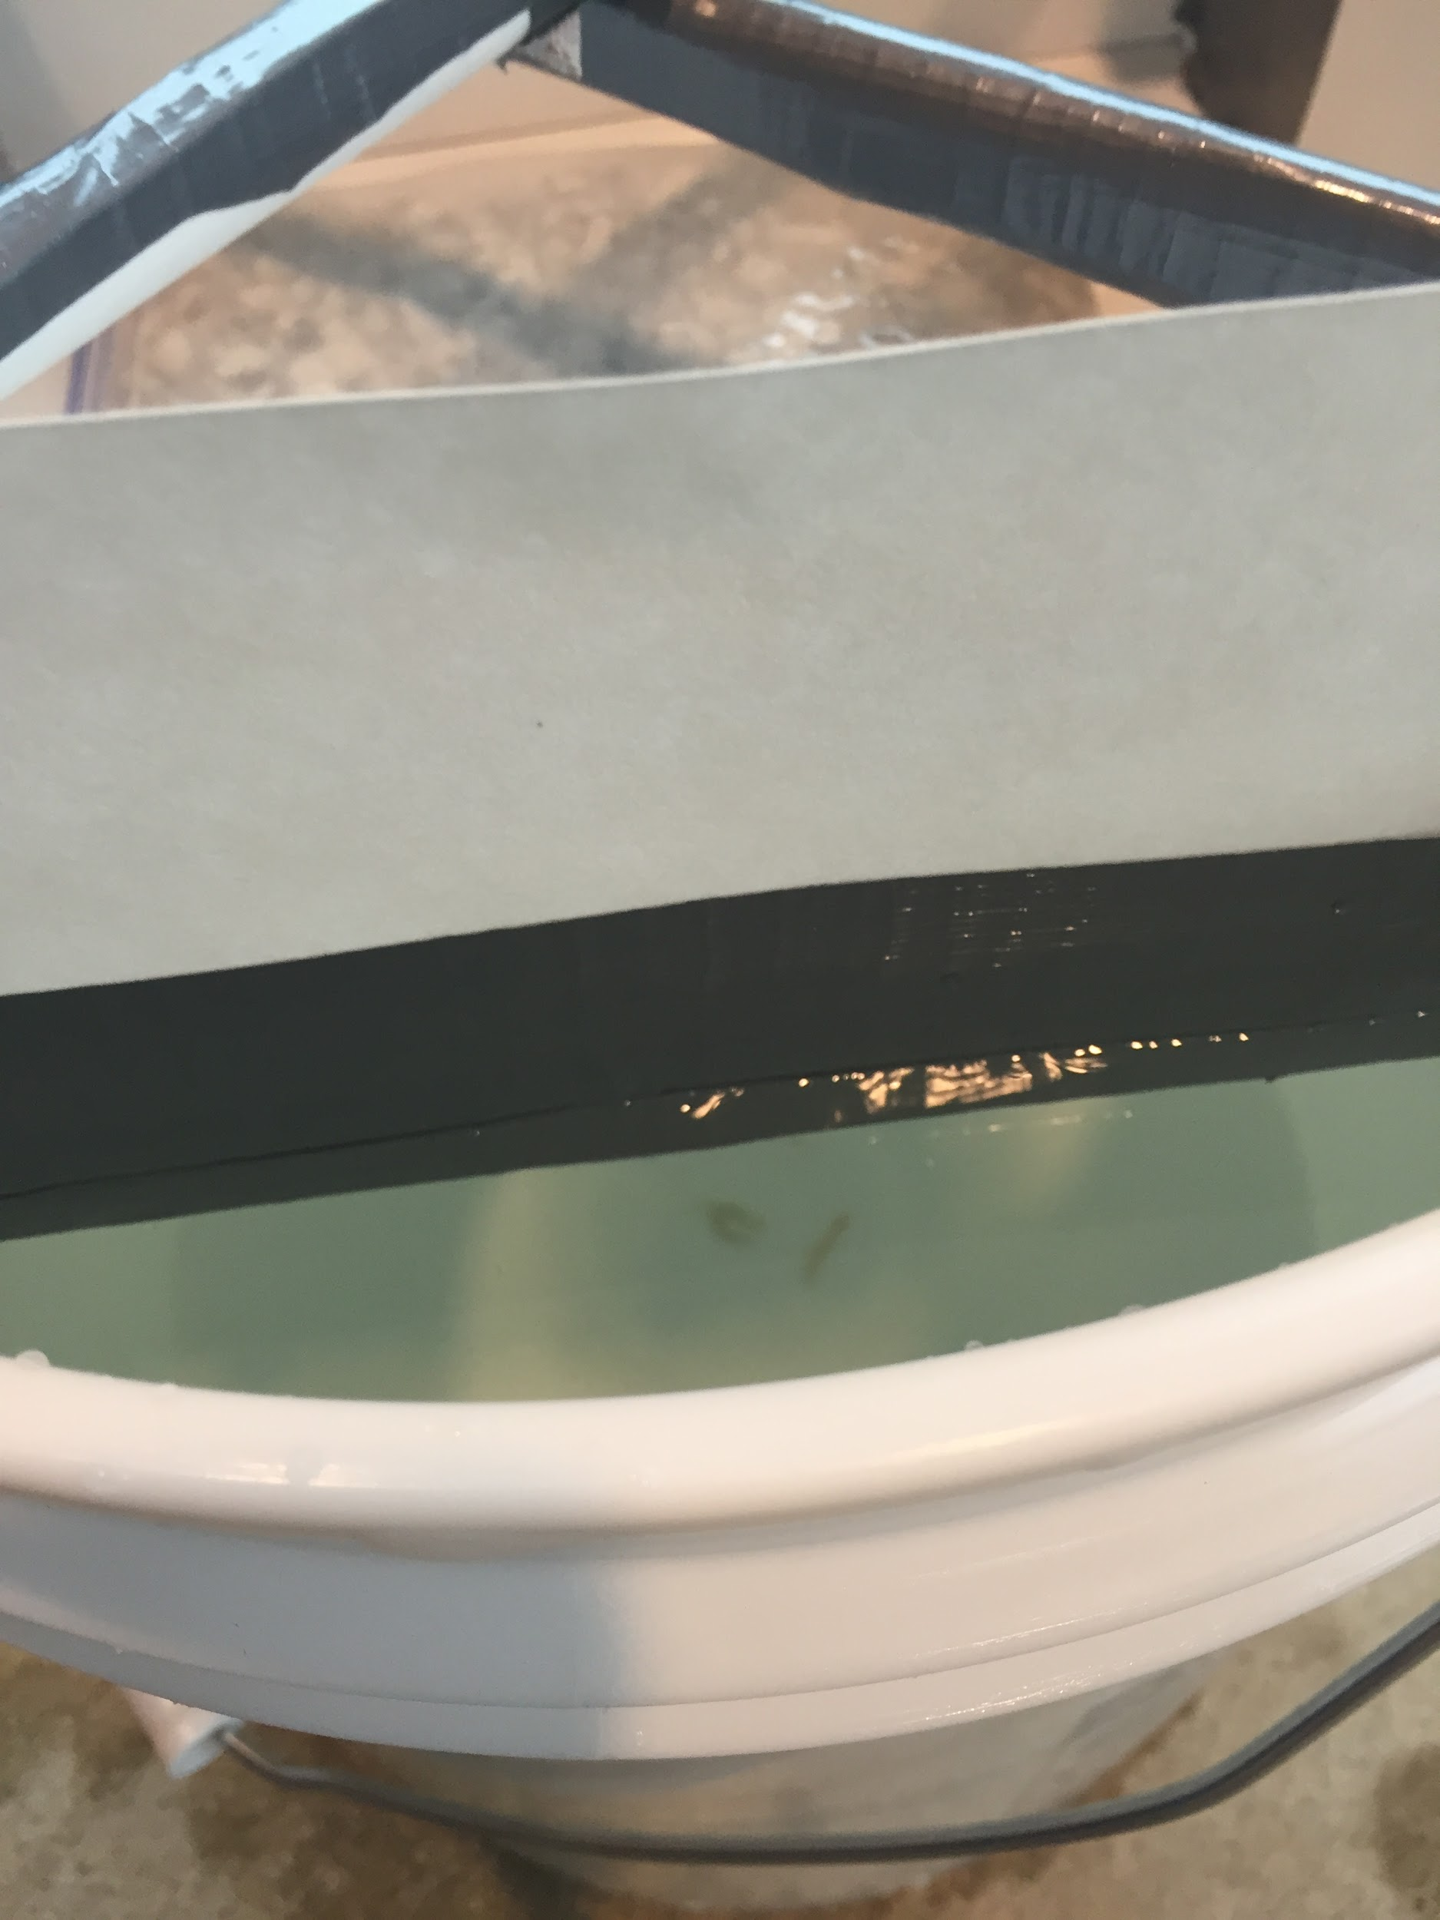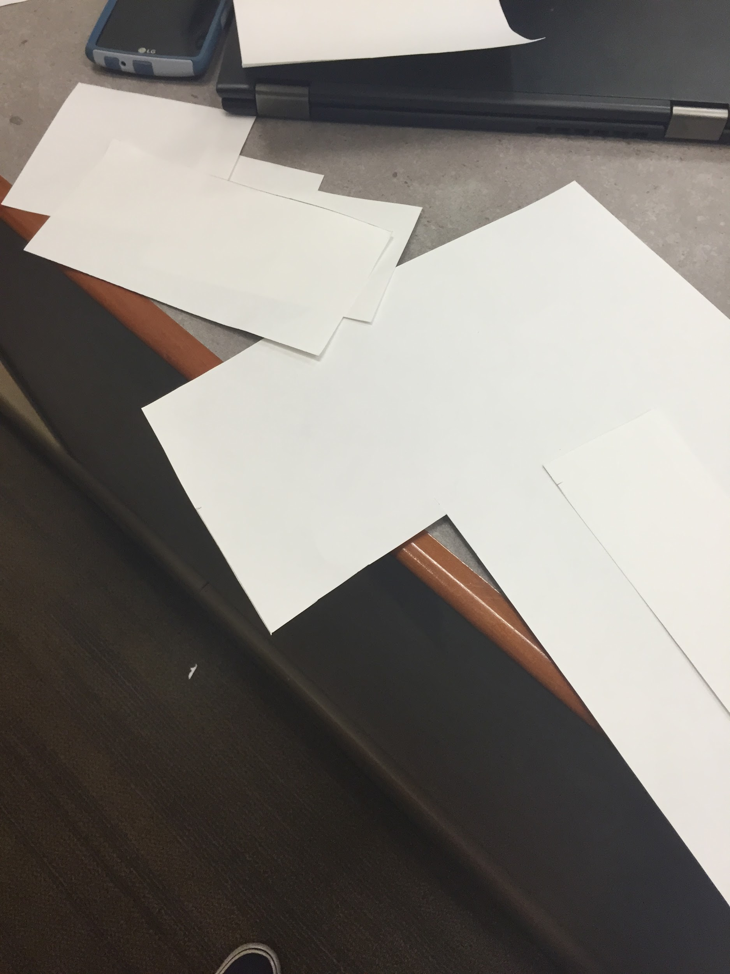

**COLLECTED DATA:**

* Radius of water bucket ≈ 10.625 in
* Mass of gravel = 0.541kg
* Weight of boat system = 0.631 kg

**SOLUTION:**

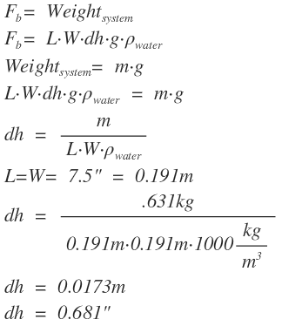

**REFLECTION:**

This project represents well that the simplest option is often the best. While it may have been more interesting to make something besides a basic box, the ability of a box to maximize the area of the base by making the diagonals of our square base just slightly smaller than the radius of the bucket is very useful. A large base area, after all, minimizes dh and makes the boat much more stable Also, a box is simply incredibly easy to make, and is very simple to waterproof, especially when compared to designs that would require curved surfaces. In fact, the only major issue with this design is the tendency of the sides to bow inwards once water is pressing against them. Here, though, that issue was circumvented with cross bars, which provide the boat incredible rigidity. This boat may not be fancy, but it works incredibly well.

It is also worth noting that the dh calculations used were very accurate, as the waterline when the boat was floated was exactly where it was predicted to be, although it did take a bit of shifting the load to get the boat to float exactly evenly.